3. Draw and validate Flowchart to compute quotient and remainder between two integers can be calculated by using the division ( / ) and modulus ( % ) operators respectively. To compute the remainder of the division of two floating point numbers, the library function f-mod() is used. This function considers quotient as an integer number and the remainder as a floating-point number.

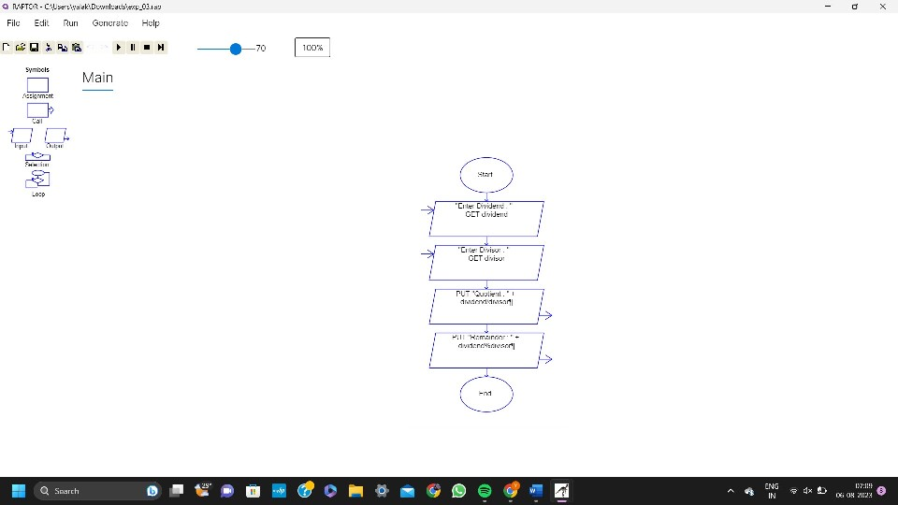4. Design a shopping cart system. How is the cart updated when the application is open on multiple pages? When an item is added to the cart, store the update in the server. Therefore, a page refresh on any tab will keep everything up to date. If you don't want to rely on a refresh, you could try some sort of polling mechanism. If the web browser on Focus event happens (assuming it's there), poll the server for a quick update if there is one.

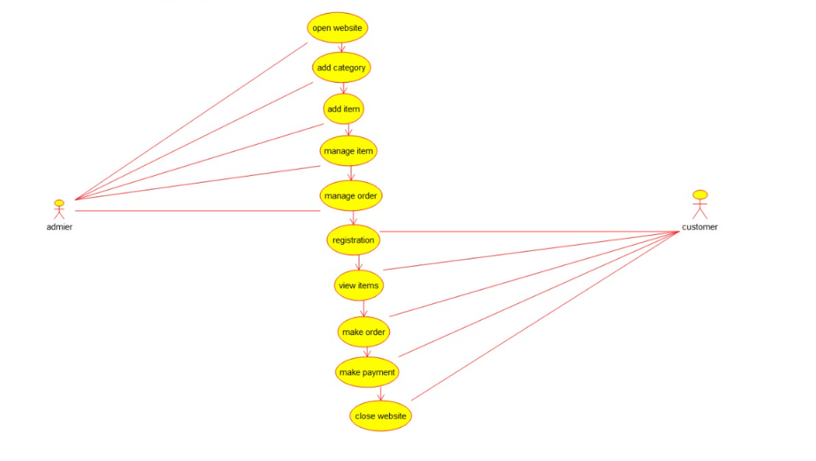

18. Using Raptor- Draw the flowchart to check whether the given number is a palindrome or not. This scenario is a word, number, phrase, or other sequence of symbols that reads the same backwards as forwards. AdaptA method for this problem is to reverse digits of number, compare the reverse of number. If both are same, then return true, else false using Raptor tool.

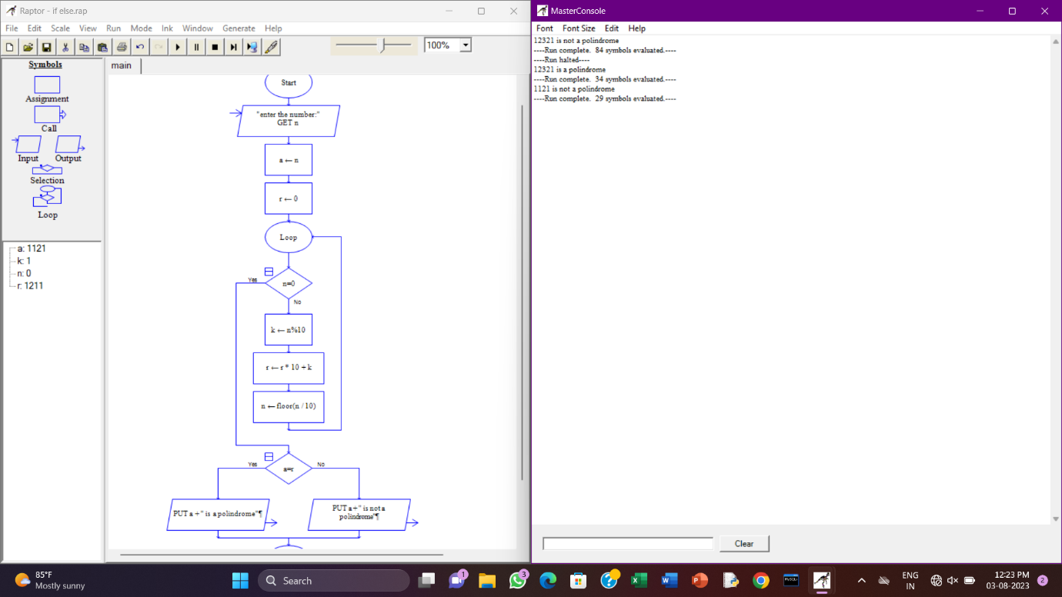

19. Using Raptor – Draw and validate a flowchart for a given string of lower-case English alphabets. One can choose any two characters in the string and replace all the occurrences of the first character with the second character and replace all the occurrences of the second character with the first character. Using Raptor draws and validates the flowchart lexicographically smallest string that can be obtained by doing this operation at most once.

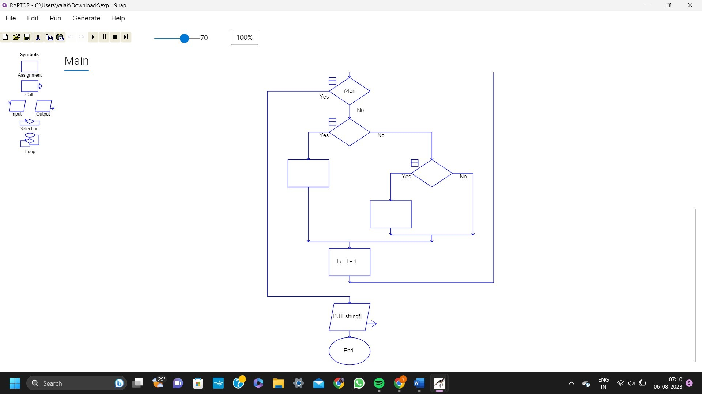

20. The string is a sequence of characters placed in double quotes (” “). Performing different operations on string data is called String Handling. Strings are immutable. Whenever a change to a String is made, an entirely new String is created. If we want to store a group of characters we can use a char array. String provides various methods to perform different operations on strings Using Raptor draw a flowchart to display the total number of characters in the string and return it.

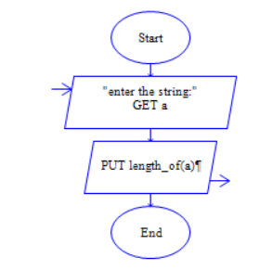

21. Take for example the RSA encryption system: All arithmetic is done modulo n, with n=pq and p, q large primes. Decryption in this system relies on computing Euler's phi function, φ(n), which is hard to compute (hence the system is hard to break) **unless** you know the prime factorization of n (which is also hard to compute unless you know it upfront). Hence you need a method to generate primes (the Miller-Rabin primality checking algorithm is usually used here) and then you construct n by multiplying the primes you have found. Using Raptor, draw the flowchart to find whether p and q are prime or not.

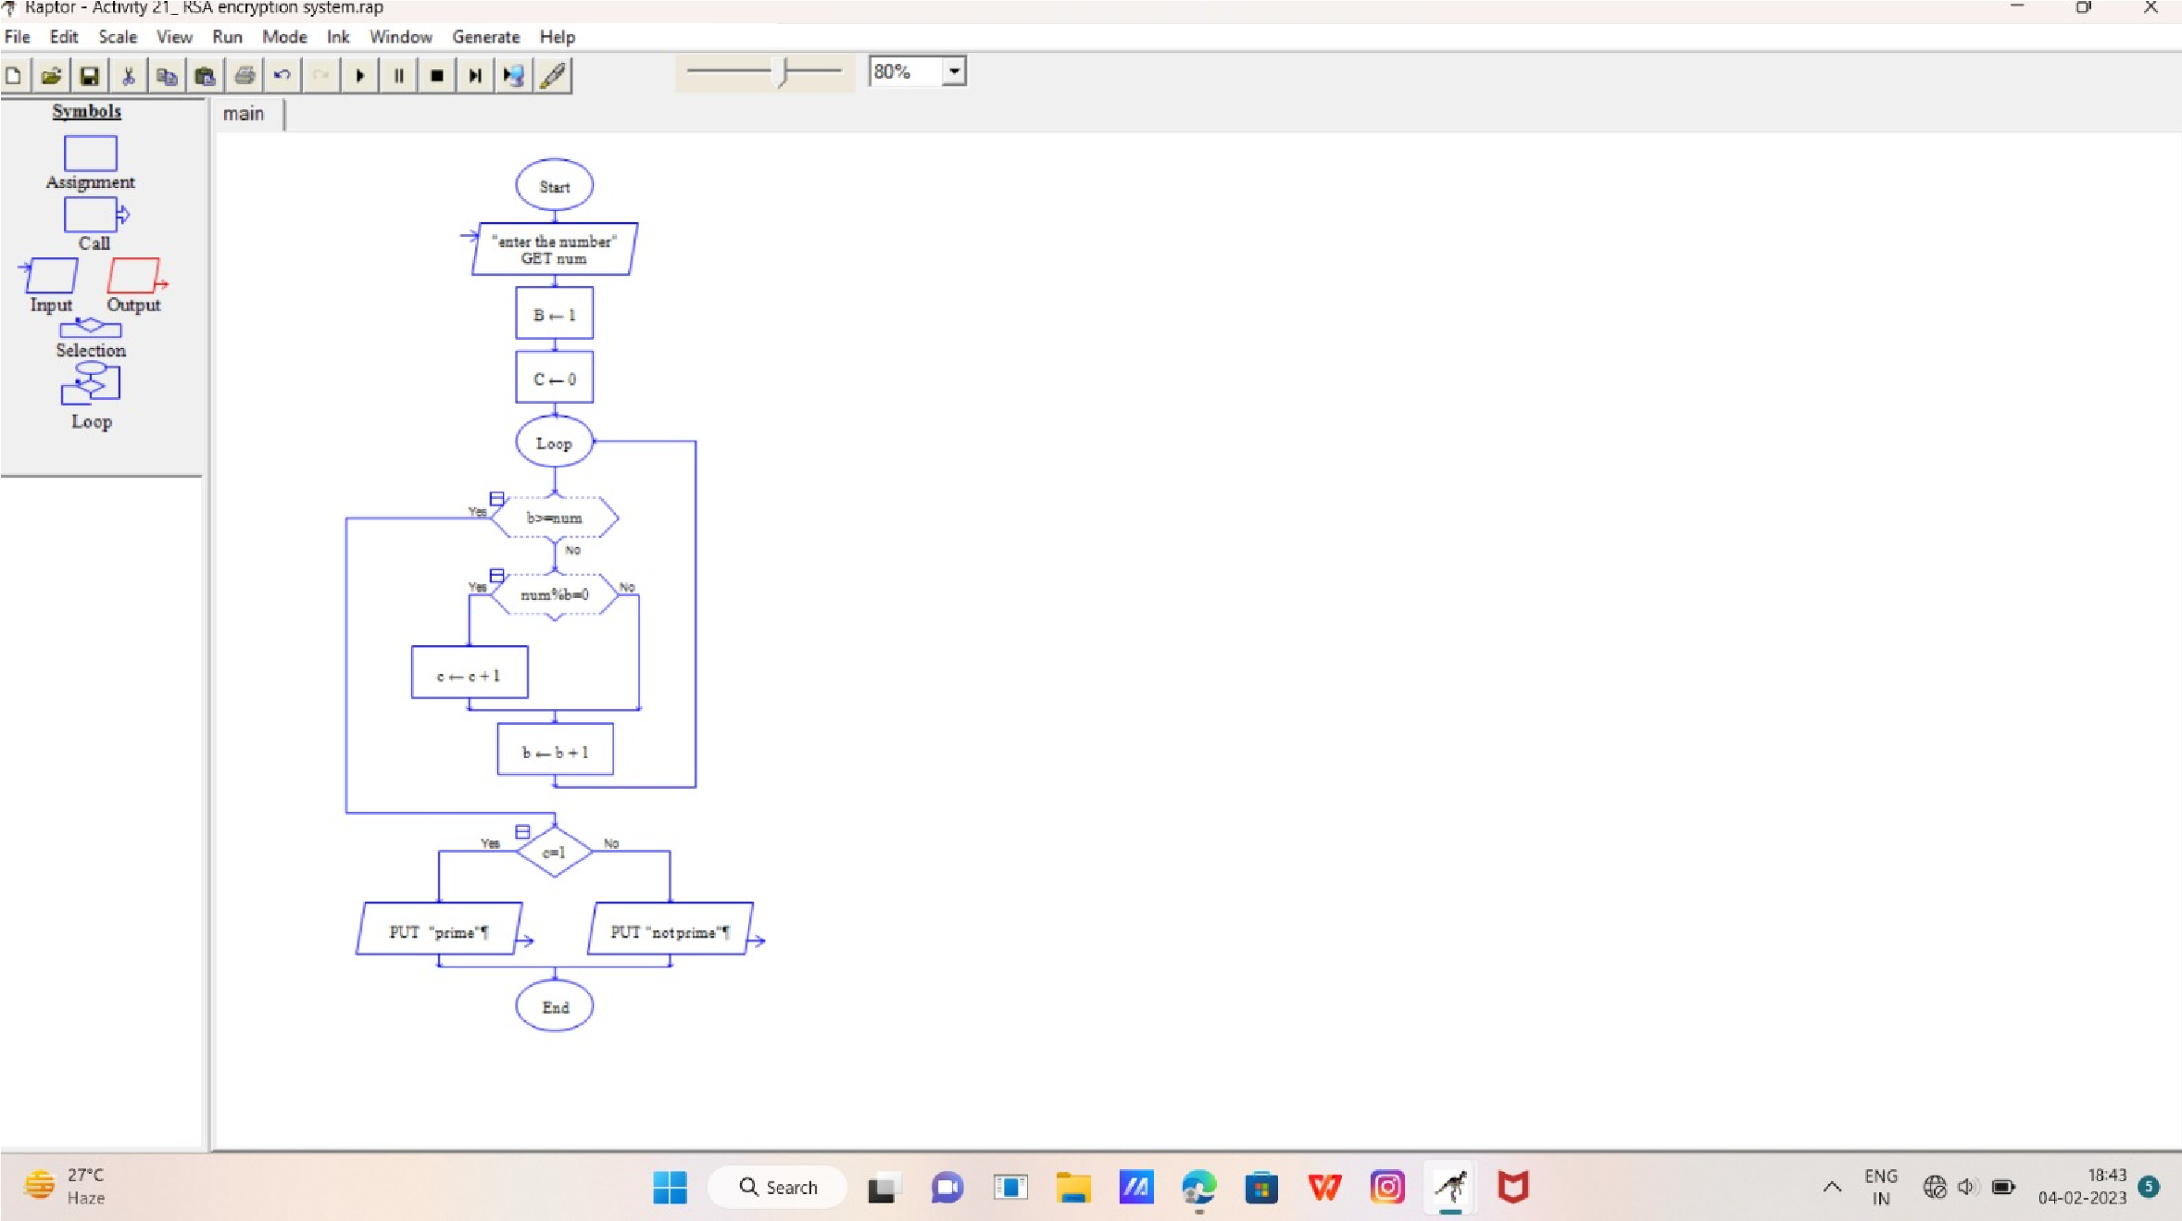

22. Cyclomatic Complexity in Software Testing is a testing metric used for measuring the complexity of a software program. It is a quantitative measure of independent paths in the source code of a software program. Cyclomatic complexity can be calculated by using control flow graphs or with respect to functions, modules, methods or classes within a software program. Cyclomatic complexity for a flow graph G is V(G)=E-N+2.Cyclomatic complexity is a software metric (measurement), used to indicate the complexity of a program, Cyclomatic complexity = E - N + P where, E = number of edges in the flow graph, N = number of nodes in the flow graph, P = number of nodes that have exit points. Find Cyclomatic Complexity for a graph having number of edges as 17, number of nodes as 13 and number of predicate nodes in the flow graph as 5

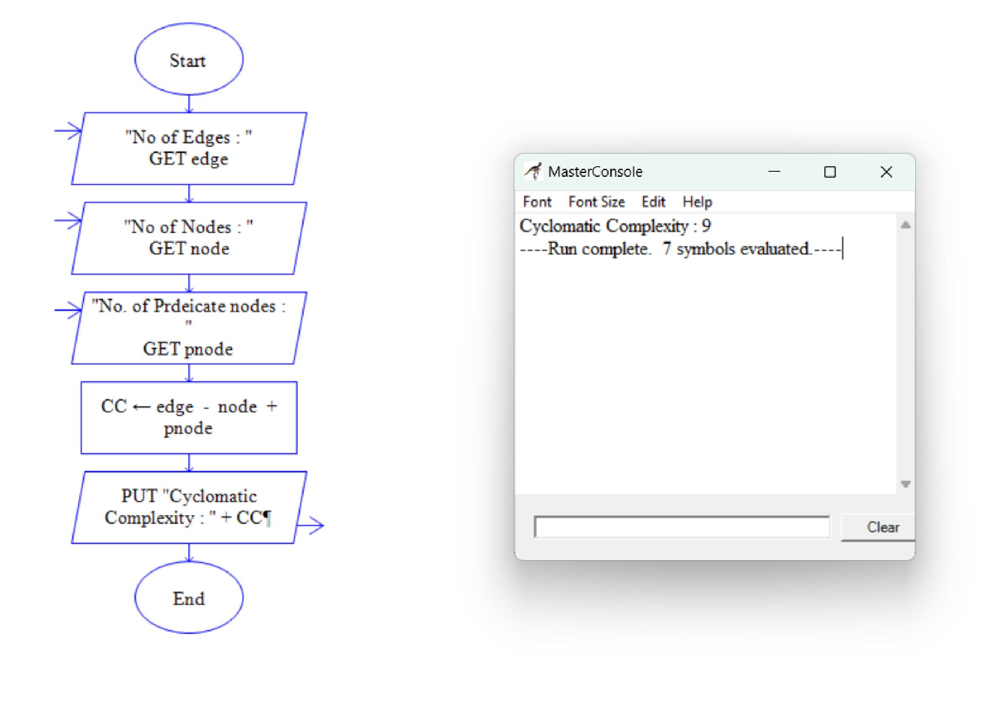

30. Using Raptor- Draw and validate the flowchart to calculate Factorial of a number. Factorial of a positive integer (number) is the sum of multiplication of all the integers smaller than that positive integer. For example, factorial of 5 is 5 * 4 * 3 * 2 * 1 which equals 120

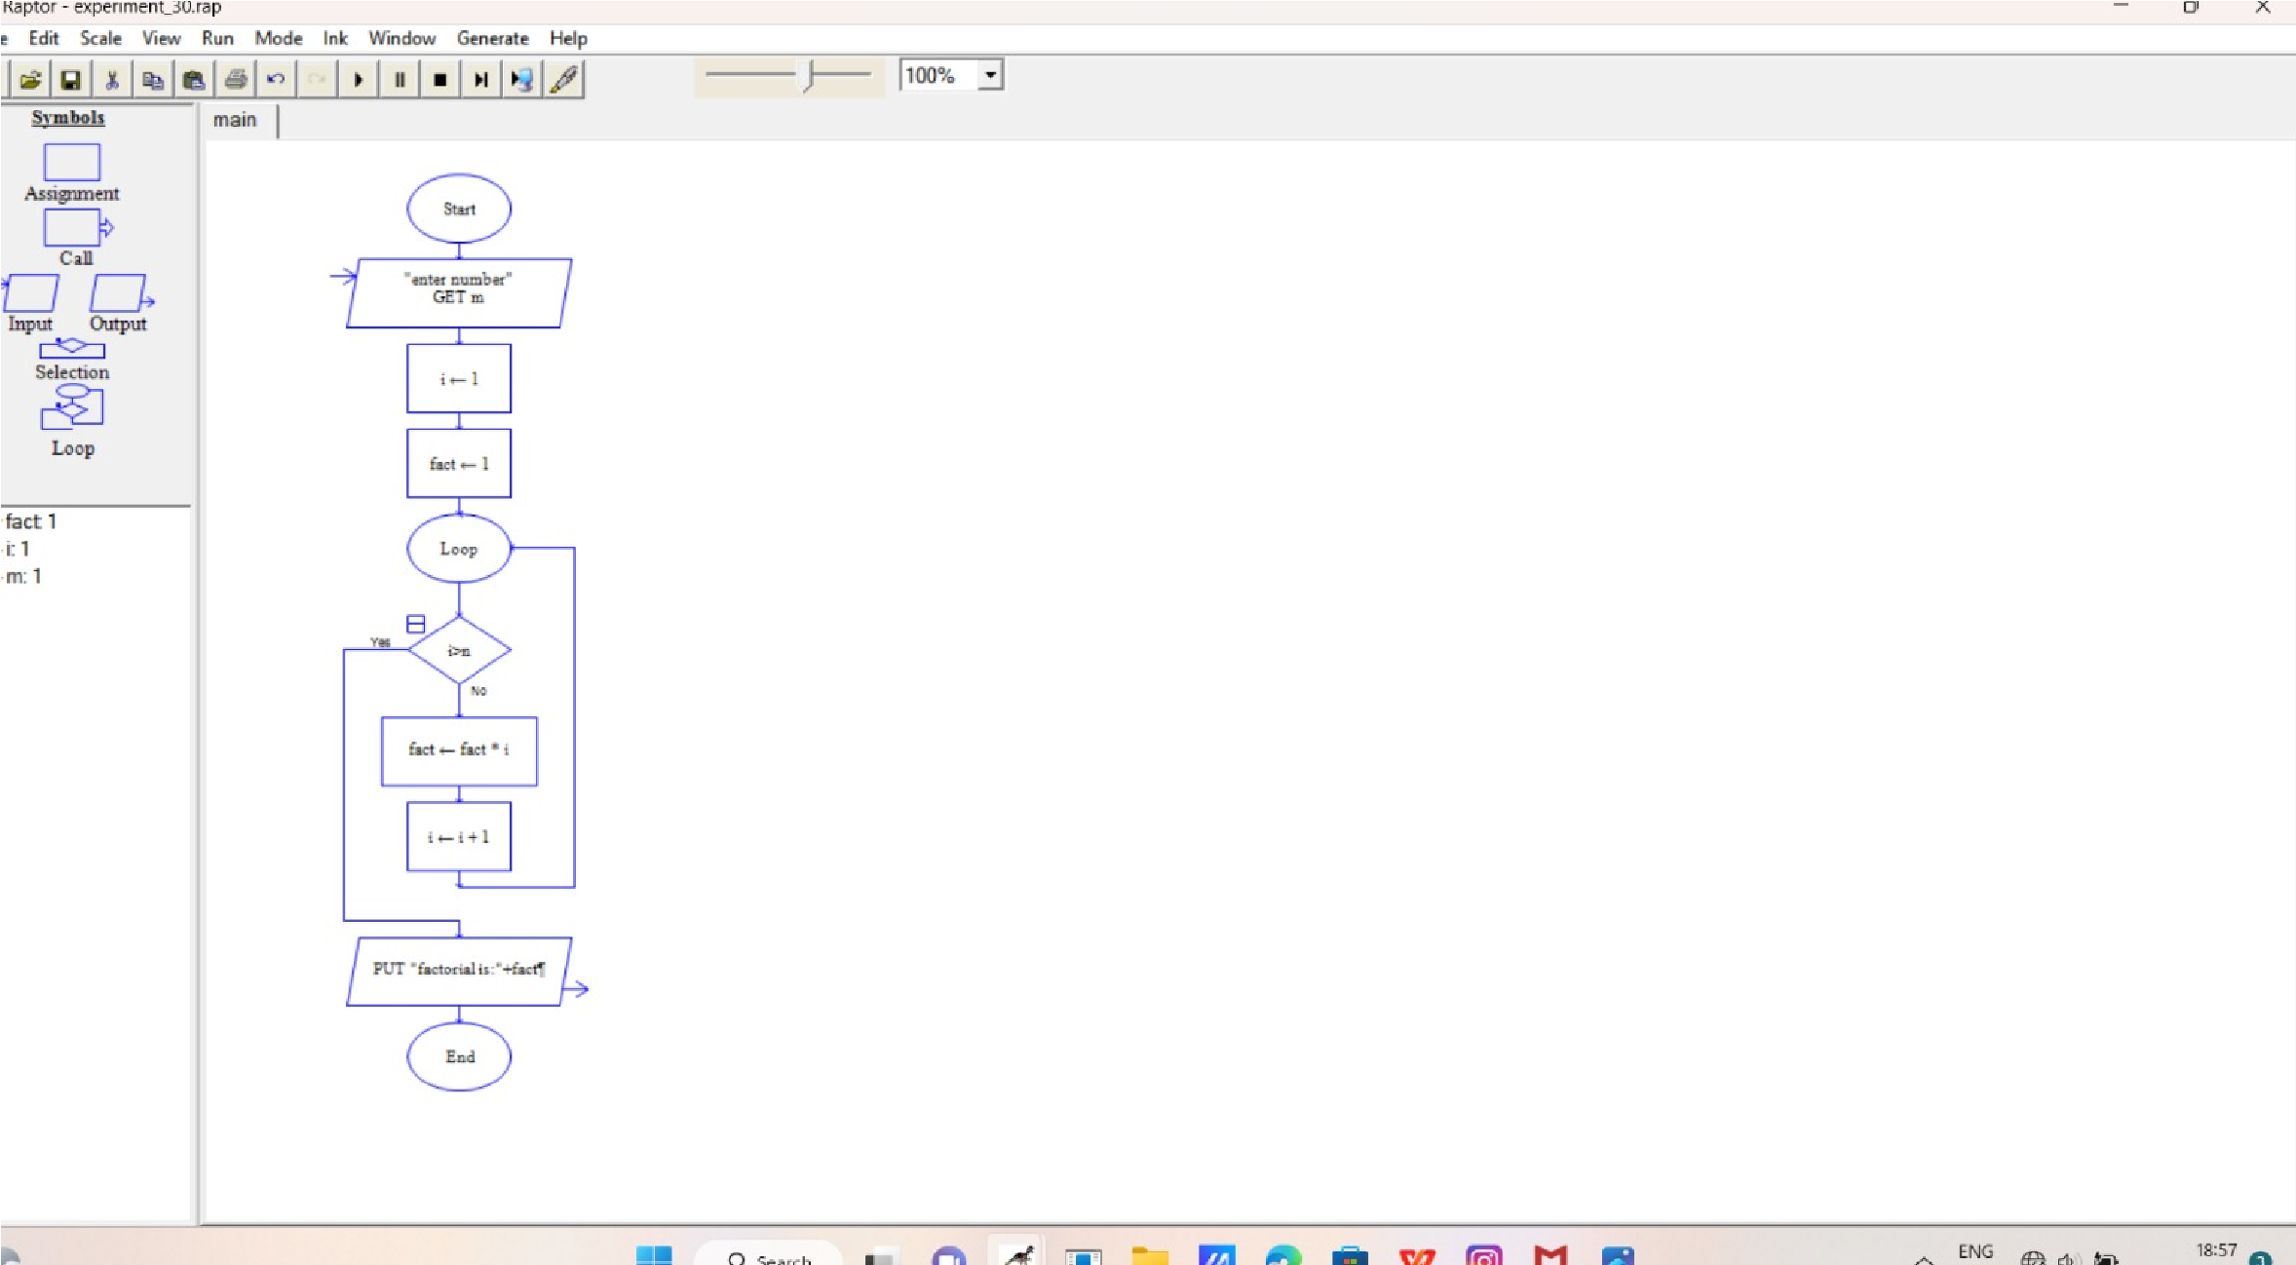

31. Using Raptor – Draw and validate the flowchart to find odd series of the given number. The odd numbers are the numbers which are not divisible by 2. They are 1,3,5,7,9,11,13,15,17,19 etc.. Using Raptor – Draw and validate the flowchart to find even series of the given number

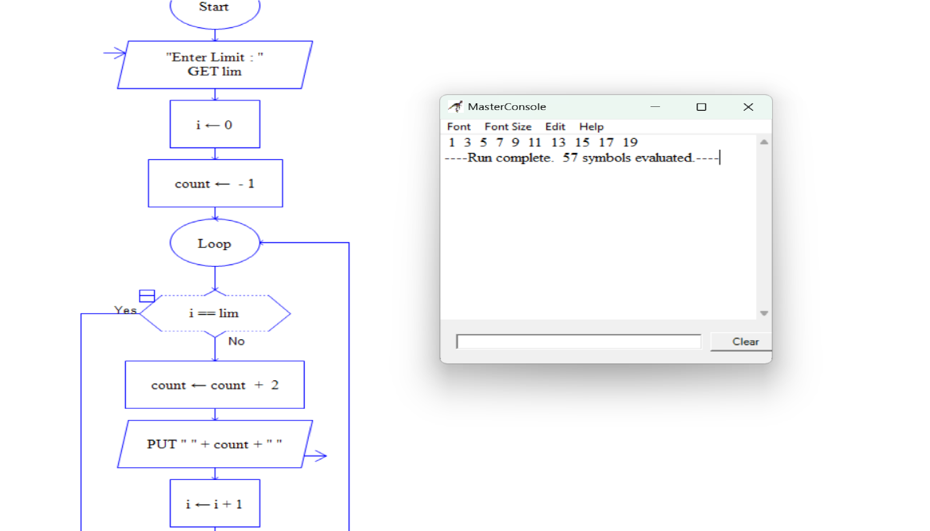

32. Draw the flowchart that uses Raptor, how to reverse a given String. If the string is "hello" then, the output should be "olleh". We can use this concept to check the palindrome. Because the palindrome string will have the same value even after we reverse it.

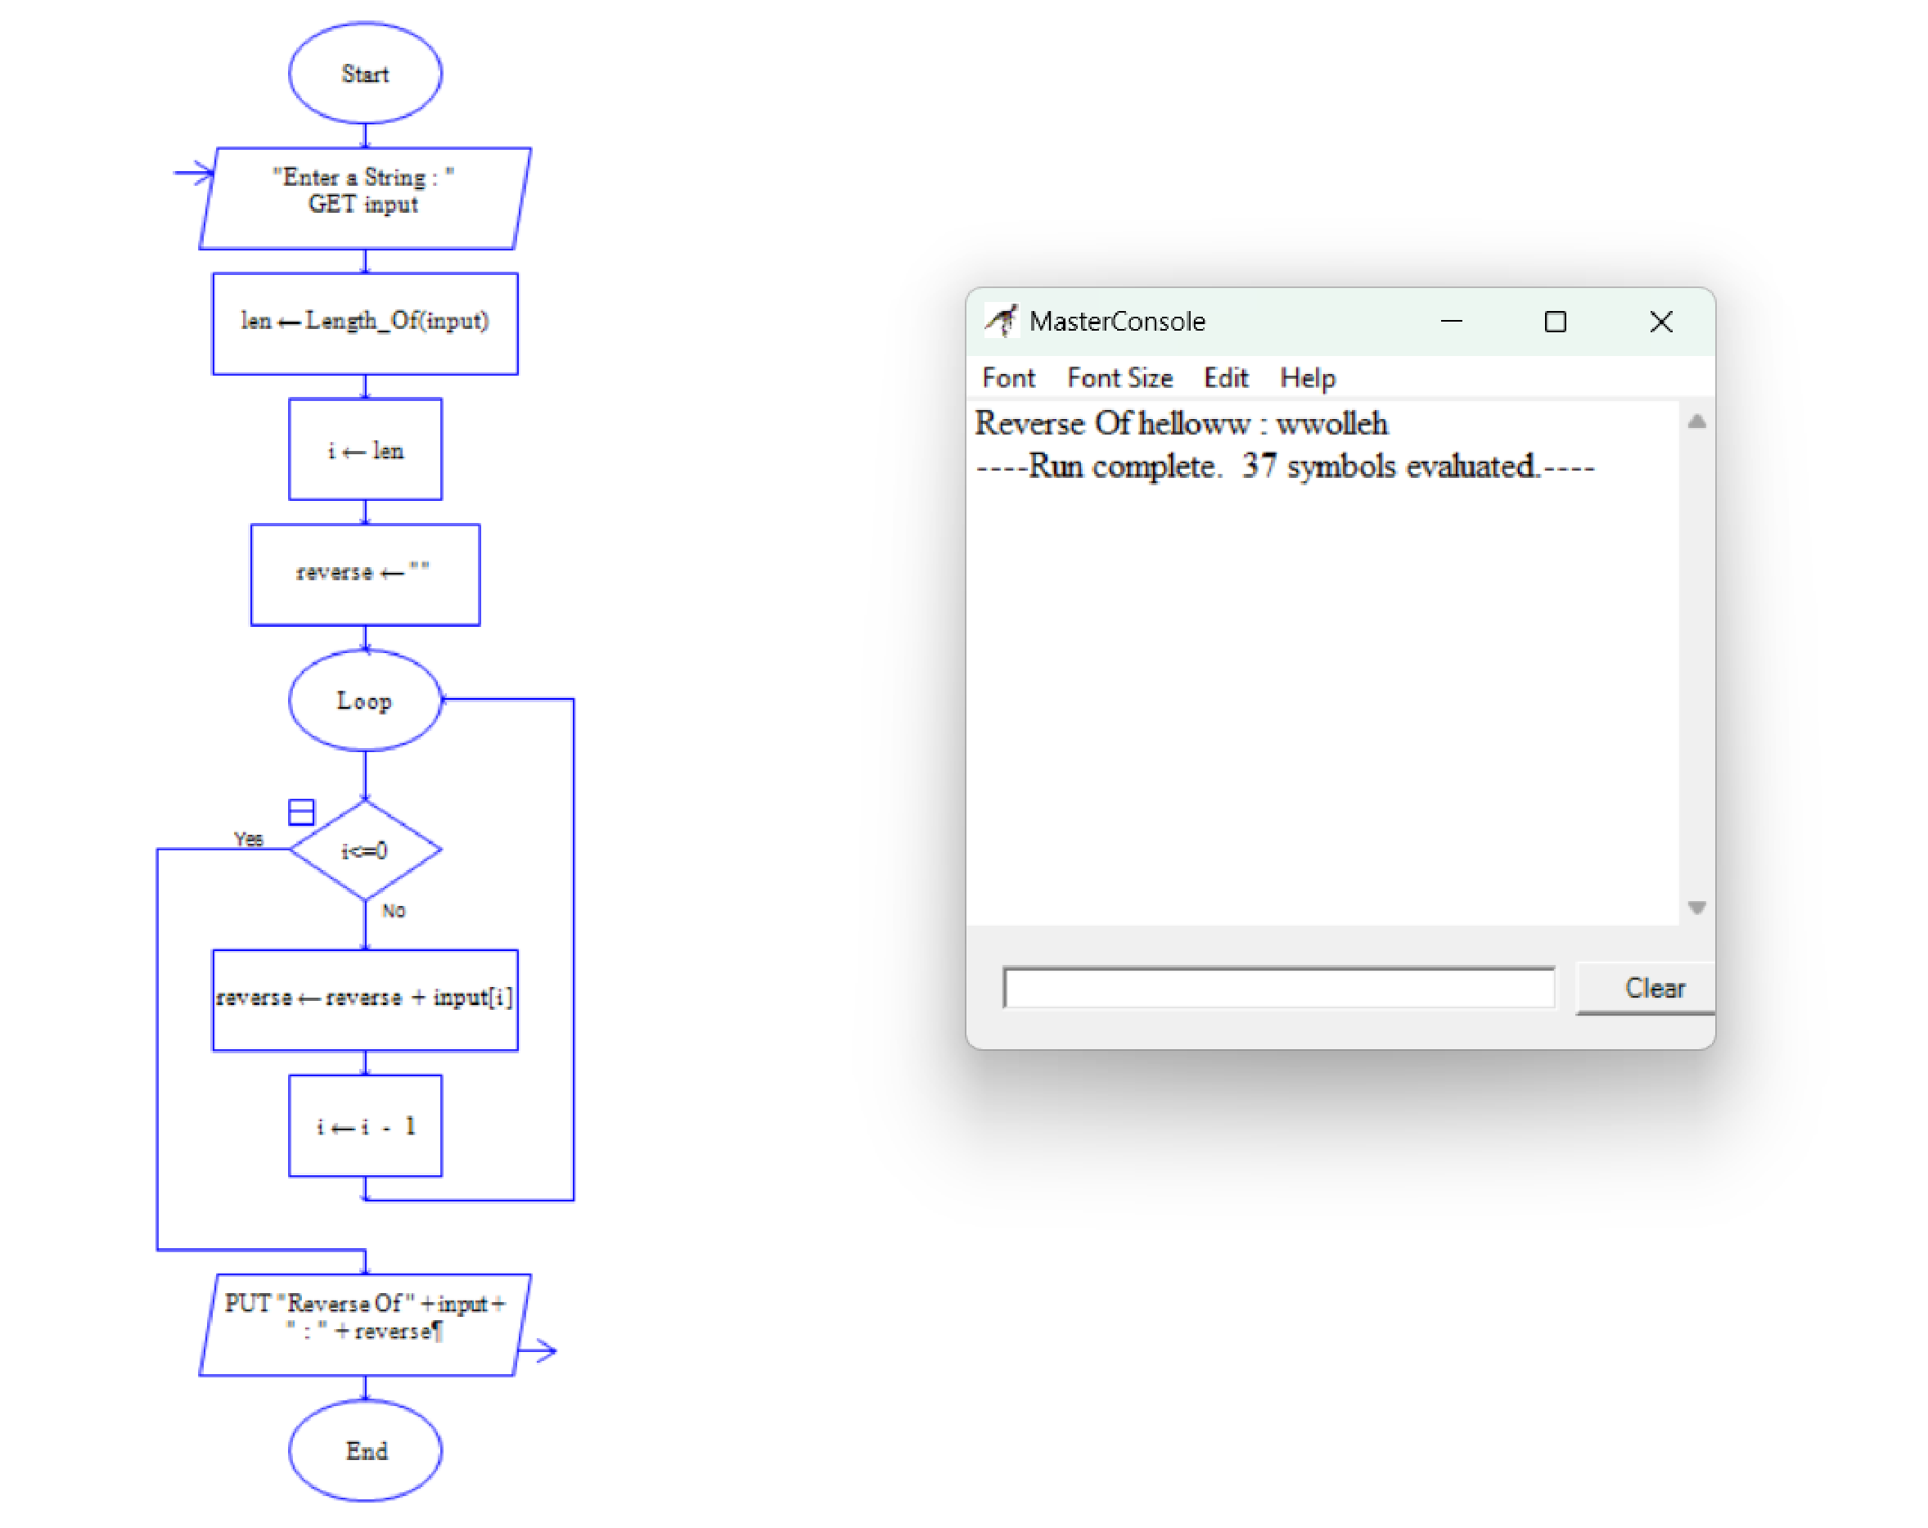

33. Draw the flowchart using Raptor, The formula of the sum of first n natural numbers is S=n(n+1)2S=n(n+1)2 . If the sum of first n natural number is 325 then find n. Using Raptor – Draw the flowchart to find largest of n numbers.

